**Create a Workspace and a Compute Instance**

In this tutorial, you'll create a **workspace** and a **compute** **instance** necessary to work with Azure ML projects.

* **W*orkspace***. To use Azure Machine Learning, you'll first need a workspace. The workspace is the central place to view and manage all the projects and resources you create.
* **C*ompute instance***. A compute instance is a pre-configured cloud-computing resource that you can use to train, automate, manage, and track machine learning models. A compute instance is the quickest way to start using the Azure Machine Learning SDKs and CLIs.

You must have an Azure account with an active subscription.

**Create the workspace**

The workspace is the top-level resource for your machine learning activities, providing a centralized place to view and manage the artifacts you create when you use Azure Machine Learning.

1. Sign in to [Azure Machine Learning studio](https://ml.azure.com/)
2. Select **Create workspace**
3. Provide the following information to configure your new workspace:

| **Field** | **Description** |
| --- | --- |
| Workspace name | Enter the name such as FirstName_LastName_Workspace so that you know this is your own workspace. Names must be unique across the resource group. Use a name that's easy to recall and to differentiate from workspaces created by others. The workspace name is case-insensitive. |
| Friendly name | This name is not restricted by Azure naming rules. You can use spaces and special characters in this name. |
| Hub | A hub allows you to group related workspaces together and share resources. If you have access to a hub, select it here. If you don't have access to a hub, leave this blank. |
|  |  |

1. For the advanced settings, the values should be already in for you. If not, look at the Advanced settings table below to enter those values.

**Advanced Settings Table**

| **Field** | **Description** |
| --- | --- |
| Subscription | Select the Azure subscription that you want to use. |
| Resource group | Use an existing resource group in your subscription or enter a name to create a new resource group. A resource group holds related resources for an Azure solution. You need *contributor* or *owner* role to use an existing resource group. For more information about access, see [Manage access to an Azure Machine Learning workspace](https://learn.microsoft.com/en-us/azure/machine-learning/how-to-assign-roles?view=azureml-api-2). |
| Region | Select the Azure region closest to your users and the data resources to create your workspace. |

1. Select **Create** to create the workspace

**Create a compute instance**

We use a *compute instance* in case we need to run Jupyter notebooks and Python scripts. Let us create one now:

1. Select your workspace.
2. On the top right, select **New**.
3. Select **Compute instance** from the list.

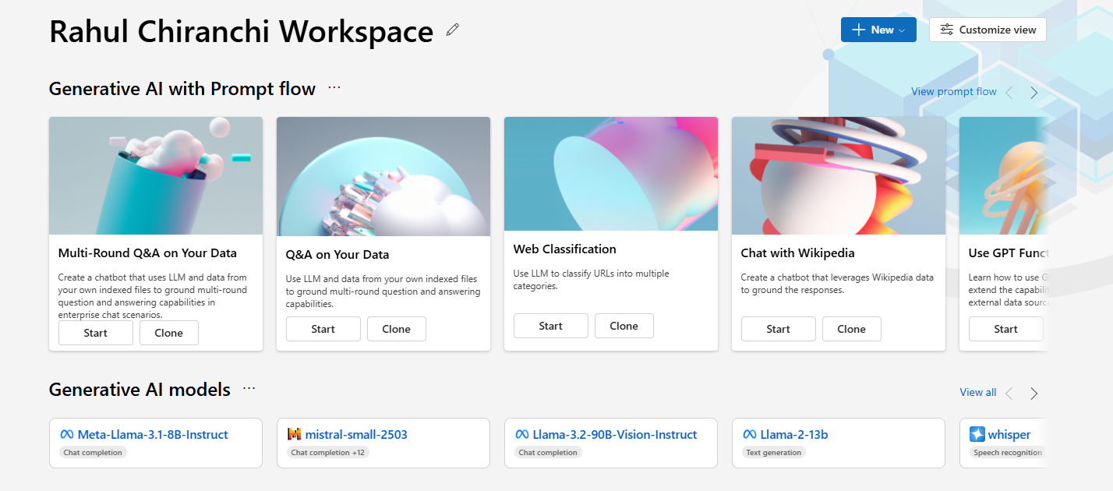

1. Leave the suggested name for the compute instance.
2. Keep the default values for the rest of the page.
3. Click **Review + Create**
4. Click **Next**
5. Select **Create**. It will take some time for your compute instance to be created.

**Clean up resources**

If you plan to continue now to other tutorials, skip to [Next step](https://learn.microsoft.com/en-us/azure/machine-learning/quickstart-create-resources?view=azureml-api-2#next-step).

**Stop compute instance**

If you're not going to use it now, stop the compute instance:

1. In the studio, on the left menu, select **Compute**.
2. In the top tabs, select **Compute instances**
3. Select the compute instance in the list.
4. On the top toolbar, select **Stop**.